**1)Audience Age Breakdown: Students vs. Educators and Principals:-**

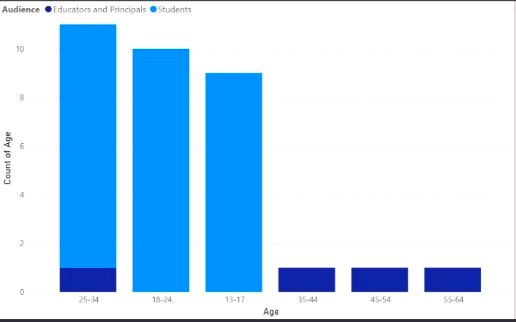

**The bar chart categorizes ages into six groups: 13-17 years, 18-24 years, 25-34 years, 35-44 years, 45-54 years, and 55-64 years. The y-axis represents the count of individuals within each age group. The two audience categories are differentiated by color, with Educators and Principals represented in dark blue and Students in light blue.The 25-34 age group has the highest total count of individuals, with 11 in total. Among these, approximately 10 are**

**students, and only about one individual is an educator or principal. The 18-24 age group follows with 10 individuals, all of whom are students. Similarly, the 13-17 age group has 9 individuals, all of them students.In contrast, the older age groups (35-44, 45-54, 55-64) each have only one individual, all of whom are educators or principals. There are no students in these age groups. This highlights a clear distinction where younger age groups are predominantly composed of students, while older age groups are exclusively educators and**

**principals.**

**So, we can draw an insight that the audience Student within the age group 25-34 has the highest share of engaging in the Ads.**

**2) Maximum amount spent in INR by a Campaign:-**

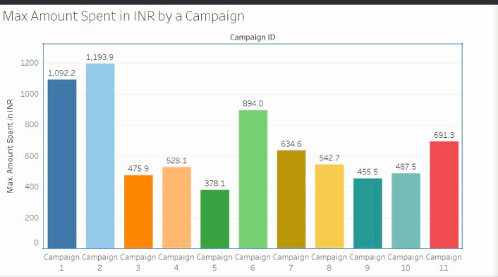

**The X-axis shows the Max amount spent and y-axis shows the Campaign Id.The data reveals that Campaign 2 has the highest expenditure, reaching 1,193.9 INR, followed closely by Campaign 1, which spent 1,092.2 INR. On the other end of the spectrum, Campaign 5 exhibits the lowest spending at 378.1 INR.Moderate spending is observed in Campaigns 3, 4, 7, 8, 9, and 10, with expenditures ranging from 455.5 INR to 634.6 INR. Notably, Campaign 6 stands out with a significant spending amount of 894.0 INR. Campaign 11 also demonstrates a considerable expenditure of 691.3 INR, although it does not rank among the top three highest spenders.Overall, the data suggests that Campaigns 1 and 2 had the most substantial financial investments, likely reflecting larger or more aggressive marketing strategies. In contrast, the lower spending of Campaign 5 might indicate a more conservative approach or a shorter duration of activity.**

**3)Minimum cost per result of a Campaign:-** 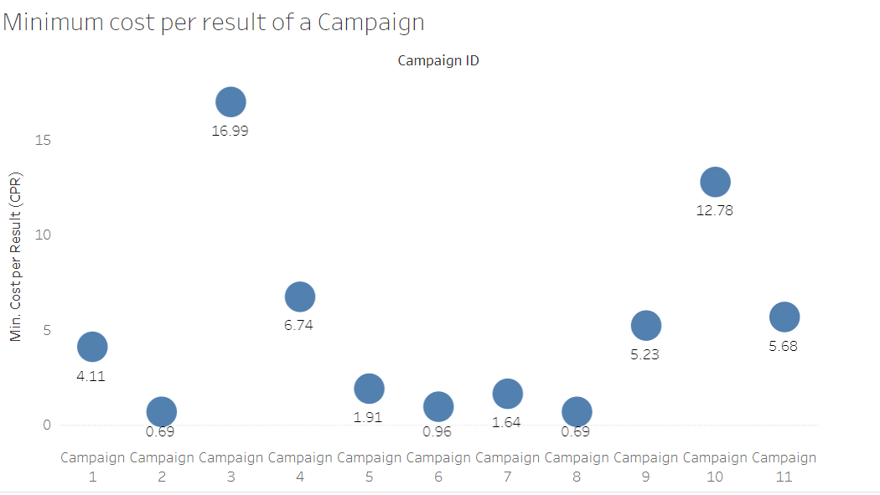

**The x-axis represents the campaign IDs , while the y-axis measures the CPR . The data reveals that Campaign 3 has the highest CPR at 16.99, indicating it is the least cost-efficient in terms of achieving results. Campaigns 2, 8, and 6 exhibit the lowest CPRs, all at 0.69, showcasing their high cost efficiency. Other campaigns like Campaign 1 (4.11), Campaign 4 (6.74), Campaign 5 (1.91), Campaign 7 (1.64), Campaign 9 (5.23), Campaign 10 (12.78), and Campaign 11 (5.68) fall in between these extremes.**

**4)Comparsion between Clicks and Unique Clicks based on the Campaign**

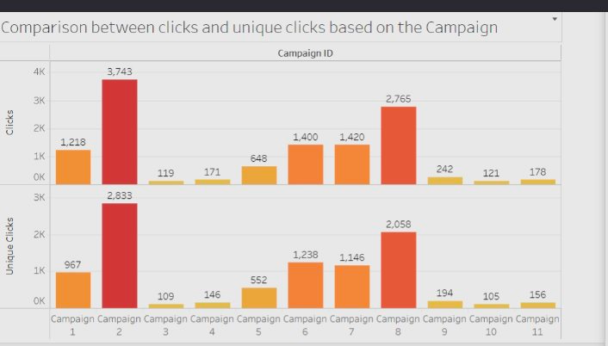

**The two sided Bar graph consists of Clicks, Unique Clicks as X-axis and Campaign Id as Y-axis. The Campaign 2 stands out with the highest number of clicks at 3,743 and unique clicks at 2,833, indicating strong user engagement. Campaign 8 follows, with 2,765 clicks and 2,058 unique clicks. Campaigns 6 and 7 also show substantial activity, with clicks around 1,400 and unique clicks over 1,100. In contrast, Campaigns 3, 4, 9, 10, and 11 exhibit low engagement, with both clicks and unique clicks remaining below 250. Overall, the data suggests that certain campaigns are significantly more effective at attracting user interaction, while others need improvement.**

**5)Impressions and Reach based on Geography**

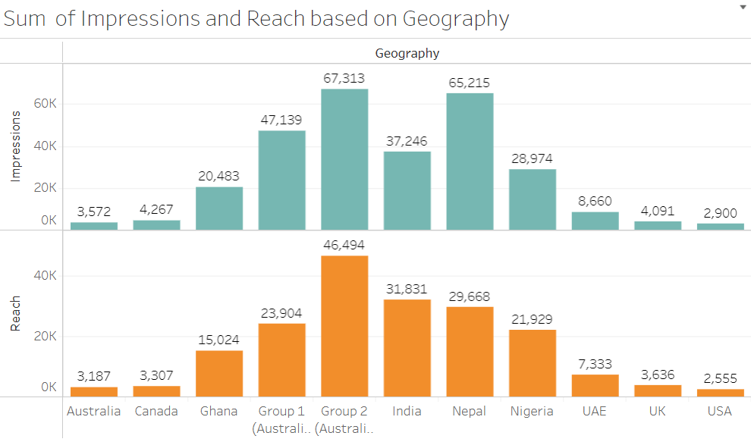

**The Bar Graph represents the sum of impressions and reach on Y-axis and geographies on X-axis. Group 2 (Australia) leads with the highest impressions at 67,313 and a reach of 46,494, indicating broad visibility and substantial engagement. Group 1 (Australia) and India also show strong performance with impressions of 47,139 and 65,215, and reach figures of 23,904 and 31,831, respectively. Nepal, Nigeria, and Ghana have moderate impressions ranging from 20,483 to 28,974 and reach between 15,024 and 21,929. Other regions like UAE, Canada, USA, and UK exhibit lower engagement, with impressions and reach figures falling below 10,000 and 7,500, respectively. The data highlights that specific regions, particularly Group 2 and India, are achieving significant outreach and engagement, while others may need targeted strategies to improve their metrics.**

**6)Average cost per Result and amount spent analysis:-**

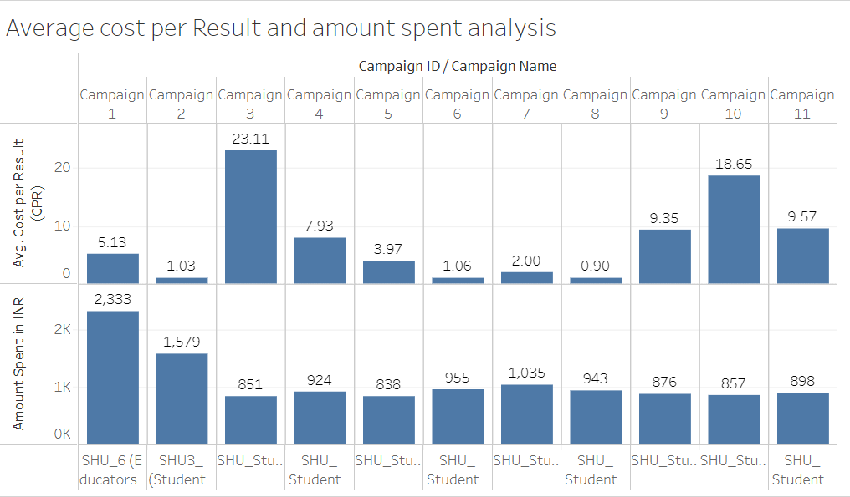

**The chart illustrates the average cost per result (CPR) and the amount spent for various campaigns. Campaign 3 exhibits the highest CPR at 23.11 INR, indicating inefficiency compared to other campaigns. Campaign 10 follows with a CPR of 18.65 INR, while Campaigns 9 and 11 also show higher costs per result at 9.35 INR and 9.57 INR, respectively. In contrast, Campaigns 8 and 6 are the most cost-effective, with CPRs of 0.90 INR and 1.06 INR. The total amount spent varies, with Campaign 1 spending the most at 2,333 INR, followed by Campaigns 2 and 5 with expenditures of 1,579 INR and 924 INR, respectively. The data suggests that while some campaigns are achieving results at a lower cost, others, notably Campaign 3, are less efficient and may require strategic adjustments to improve cost-effectiveness.**

**7)Max Reach V/S Average Clicks:-**

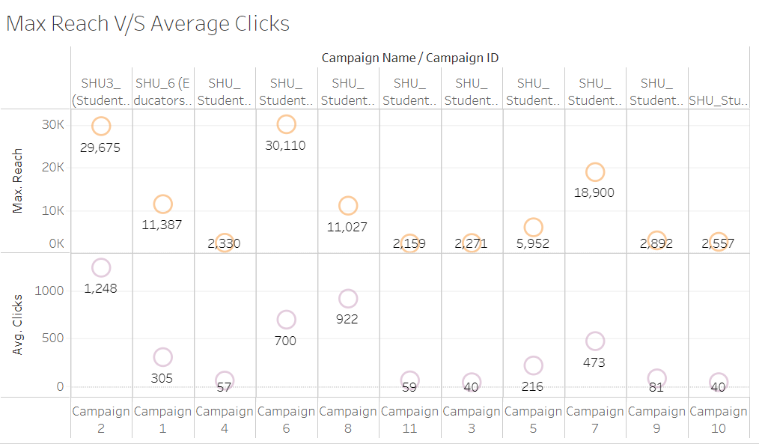

**The Bubble Chart represents max reach,average clicks on x-axis and Campaign Id on Y -axis. Campaign 2 and Campaign 6 have the highest max reach at around 30,000, while Campaign 7 follows with about 19,000. However, the average clicks don't directly correlate with reach. Campaign 2 has the most clicks (1,248), but Campaign 6, despite high reach, only garnered 700 clicks. Campaigns 11, 3, and 10 show the lowest average clicks (below 60), suggesting less engagement despite varying reach levels. This data implies that while some campaigns achieved high visibility, engagement rates varied significantly.**

**8)Average Reach Demographically:-**

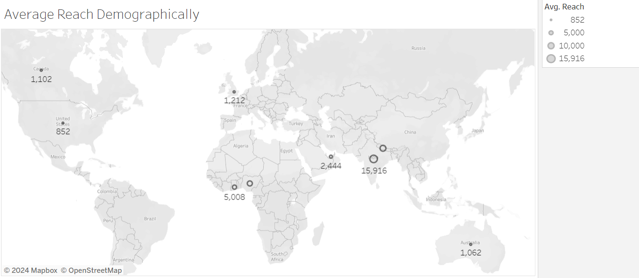

**The Demographic chart represents the average reach in a country of the campaign. The data points are represented by circles of varying sizes, corresponding to different levels of reach as indicated in the legend (852, 5,000, 10,000, and 15,916). The highest reach is observed in Asia, with 15,916 in what seems to be India or Southeast Asia. Africa shows significant reach with 5,008, while Europe has 1,212. North America is split between 1,102 (likely Canada) and 852 (USA). Australia has a reach of 1,062.**

**Asia, particularly the Indian subcontinent or Southeast Asia, shows the strongest engagement by far.Despite being developed markets, North America and Europe show lower reach numbers, which could indicate either market saturation, less targeted efforts, or lower interest in the campaign's subject matter in these regions. There's significant reach in Africa, suggesting a strong interest or targeted effort in that region.**

**9)Amount Spent on the Campaign with its Id**

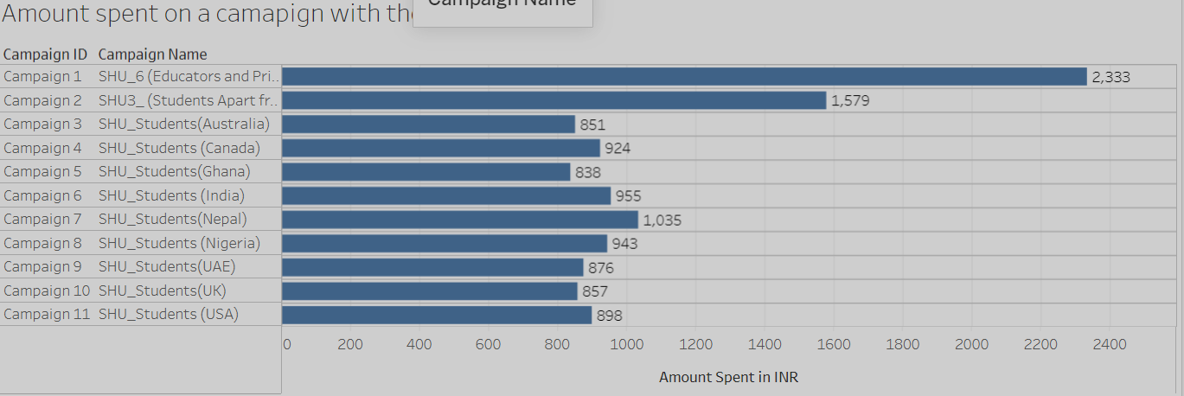

**The Horizontal Bar Chart has the Campaign Id, Campaign Name as its Y-axis and Amount Spent in INR as Y-axis.The highest spending is on Campaign 1 (SHU_6 Educators and Principal) at 2,333 INR, followed by Campaign 2 (SHU3_ Students Apart from ) at 1,579 INR, suggesting a focus on educators and a specific student segment.Campaigns targeting individual countries have varying budgets, with Nepal (1,035 INR) receiving the highest country-specific allocation, followed by Nigeria (943 INR) and the USA (898 INR).There's a global outreach effort, with campaigns targeting diverse regions including Australia, Canada, Ghana, India, Nepal, Nigeria, UAE, UK, and USA. The spending on country-specific campaigns ranges from 838 INR (Ghana) to 1,035 INR (Nepal), indicating a relatively balanced approach to international student recruitment.Interestingly, the campaign for India (955 INR) isn't the highest funded despite the chart being in INR.**

**CONCLUSION:-**

**The campaigns 6 and 8 is to be discontinued as they are not yielding the cost per result and not gaining much attention from the audience despite the amount invested on them.**